Step 5: KubernetesWe use MiniKube to prepare the application for deployment to Kubernetes. Follwing are the instructions needed for deploying the application to a Kubernetes instance.

The environment we used for deployment is Ubuntu 18 and following are the steps:

* Install Docker

Use the the following command lines to install and start Docker service:

sudo apt install docker.io

sudo systemctl enable docker

sudo systemctl start docker

* Install Minikube

Open a terminal and input the following command lines:

curl -LO https://storage.googleapis.com/minikube/releases/latest/minikube-linux-amd64

sudo install minikube-linux-amd64 /usr/local/bin/minikube

* **Install kubectl**

Use the following command line to download kubectl binary:

curl -LO https://storage.googleapis.com/kubernetes-release/release/$(curl -s <https://storage.googleapis.com/kubernetes-release/release/stable.txt)/bin/linux/amd64/kubectl>

Once kubectl is downloaded then set the executable permissions on kubectl binary and move it to the path /usr/local/bin:

chmod +x kubectl

sudo mv kubectl /usr/local/bin/

* **Start kubectl**

To start the minikube with the docker driver, run the following command:

minikube start --driver=docker --force

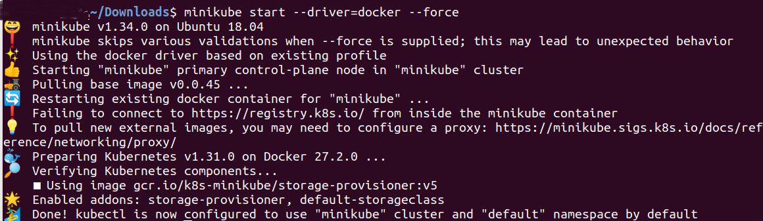

If we see this message we can proceed to next step. But make sure the cust-api docker image is available. We talked about cust-api docker image setup in document “Step 4 Containerization”.

* Use kubectl to deployment the service

**There are 2 yaml files in folder ./k8s/**

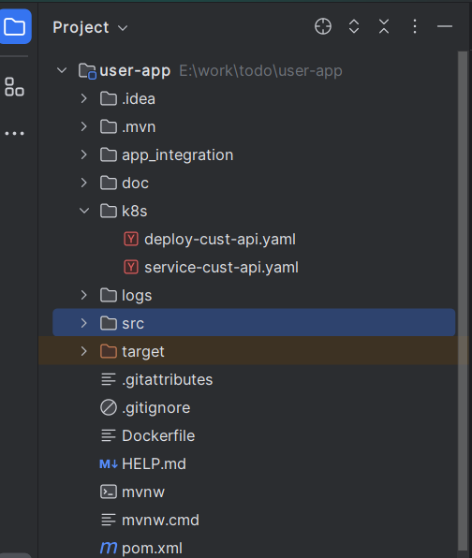

Open a terminal in ./k8s directory and run the following command lines:

kubectl apply –f deploy-cust-api.yaml

kubectl apply –f service-cust-api.api.yaml

Use the following command lines to verify the service has been deployed to the Kubernetes instance successfully:

kubectl get services

minikube service cust-api --url

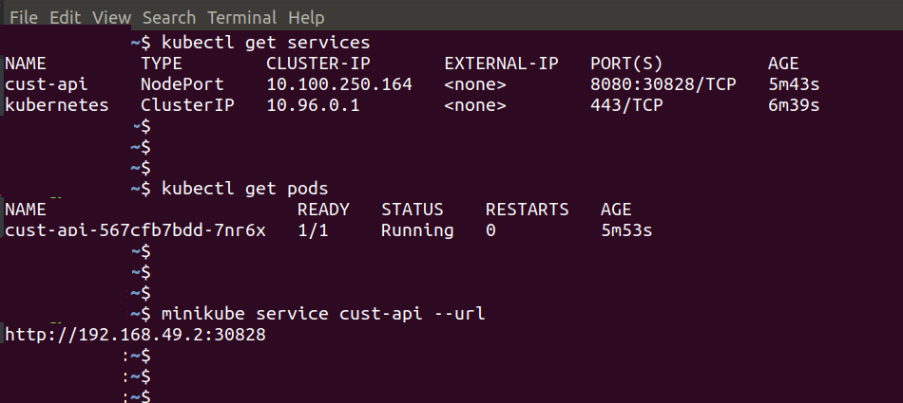

Now we can open Chrome to try the API and Swagger UI with <http://192.168.49.2:30828/swagger-ui/index.html>

